AWS REAL-TIME QUIZ
COMPETITION AND RANKING PLATFORM

Prepared by: Swathi P
AWS Region: Europe (Paris) — eu-west-3
Frontend: HTML, CSS and JavaScript | Backend: AWS Lambda (Python)

1. Project Overview
The AWS Real-Time Quiz Competition and Ranking Platform is a serverless web application that allows participants to answer AWS-related multiple-choice questions, submit their quiz, view their score, and see participant rankings on a leaderboard. The frontend is hosted on Amazon S3 static website hosting and communicates with Python AWS Lambda functions through Amazon API Gateway. Amazon DynamoDB stores participant, question, and score information.

2. Objectives
- Build a browser-based quiz application using HTML, CSS and JavaScript.
- Host frontend files on Amazon S3.
- Expose backend endpoints through Amazon API Gateway REST API.
- Use AWS Lambda with Python to retrieve questions, evaluate submissions and generate leaderboard data.
- Store and retrieve application data using Amazon DynamoDB.
- Configure CORS so the browser frontend can call the API.
- Test quiz submission, score persistence and leaderboard response.

3. AWS Architecture
Request flow:
Participant's Browser
|
v
Amazon S3 — Static Frontend (HTML/CSS/JavaScript)
|
| HTTP API requests
v
Amazon API Gateway — REST API
|
+--------------------+----------------------+
| | |
v v v
Questions Lambda Submit Quiz Lambda Leaderboard Lambda
| | |
+--------------------+----------------------+
|
v
Amazon DynamoDB
(QuizQuestions / QuizParticipants /
QuizScores)

Note: The exact Lambda function names and table names should match the names configured in the AWS account. The current project troubleshooting context confirms the QuizScores table and a QuizQuestions table; QuizParticipants was also created for registration/participant data.

4. AWS Services Used
AWS Service | Purpose in This Project
Amazon S3 | Stores and serves the static frontend files.
Amazon API Gateway (REST API) | Provides HTTP endpoints for questions, quiz submission and leaderboard retrieval.
AWS Lambda (Python) | Runs backend logic without managing servers.
Amazon DynamoDB | Stores quiz questions, participant details and quiz scores.
AWS IAM | Controls Lambda permissions to access required DynamoDB tables.
Amazon CloudWatch | Stores Lambda execution logs used for troubleshooting.

5. Application Features
- Participant registration/details collection (where enabled in the frontend).
- Retrieval of AWS quiz questions and answer options.
- Quiz answer submission and score calculation.
- Successful submission message with score, for example 4 / 5.
- Saving scores to DynamoDB.
- Leaderboard ranking based on scores.
- Refresh control to reload leaderboard data.

6. DynamoDB Data Design
Table | Purpose | Known/Expected Data
QuizQuestions | Stores quiz questions and answer options. | Question ID (the project uses the key spelling `questionsId` in the configured table), question, options, correct answer, category.
QuizParticipants | Stores participant/registration information. | Participant identifier and the registration fields configured in the application.
QuizScores | Stores submitted quiz results used by the leaderboard. | participantId, submittedAt, participantName, score, totalQuestions.

Important: DynamoDB key names are case-sensitive and must exactly match the table's configured partition/sort keys and the names referenced in the Lambda code. Confirm the actual key schema in the DynamoDB console before changing code.
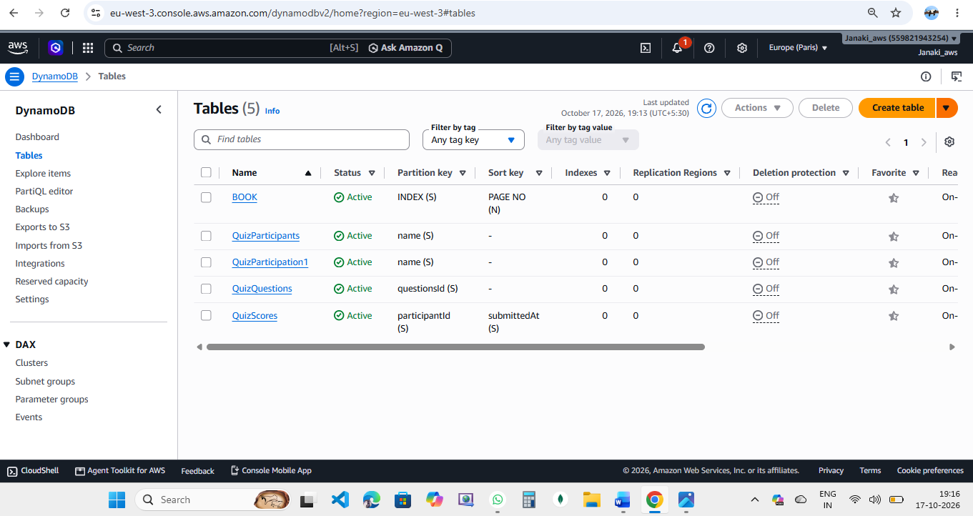

7. API Endpoints
Method | Resource Path | Purpose
GET | /questions | Returns quiz questions to the frontend.
POST | /submit | Accepts submitted answers, calculates the score and saves the result.
GET | /leaderboard | Returns ranked quiz results.
OPTIONS | Required API resources | Handles browser CORS preflight requests.

API base URL used during project testing: https://gu30xdjwwl.execute-api.eu-west-3.amazonaws.com/prod
The full leaderboard URL is the API base URL followed by /leaderboard. The full questions URL is the API base URL followed by /questions, and the submit URL is the base URL followed by /submit.
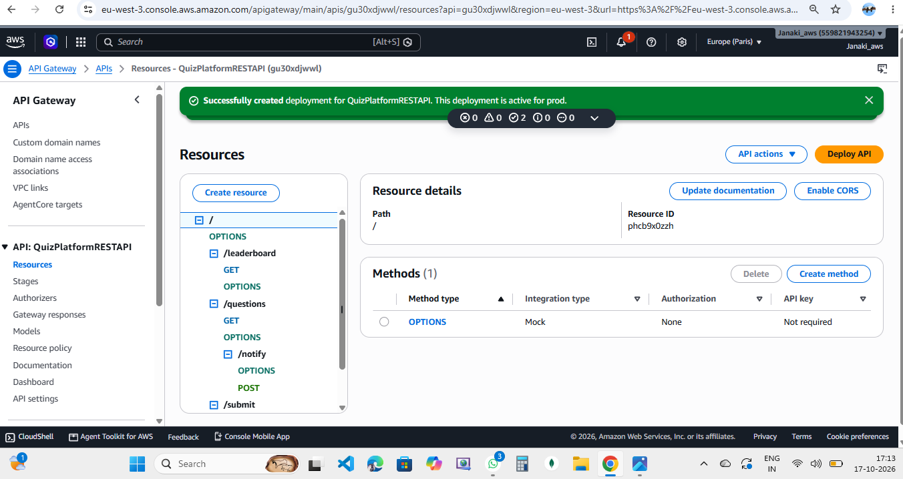

8. Frontend Deployment on Amazon S3
- Create or open the S3 bucket used for the frontend.
- Upload the project frontend files, including index.html and any CSS/JavaScript files.
- Enable static website hosting if using the S3 website endpoint, and set the index document to index.html.
- Configure bucket access according to the chosen hosting approach. For public static website hosting, allow only the required read access and never store secrets in frontend files.
- Open the deployed frontend URL in a browser and verify that the page loads.
- Ensure the frontend JavaScript uses the correct API Gateway base URL.
Frontend bucket used during testing: swathi-bucket-23. The current page was opened at /frontend/index.html.
Frontend code
Html and CSS
<!DOCTYPE html>
<html lang="en">
<head>
<meta charset="UTF-8">
<meta name="viewport" content="width=device-width, initial-scale=1.0">
<title>QuizArena | AWS Quiz Competition</title>
<link rel="stylesheet" href="styles.css">
</head>
<body>

<header class="navbar">
<div class="logo">🏆 QuizArena</div>
<span class="tag">AWS QUIZ PLATFORM</span>
</header>

<main class="container">

<section class="hero">
<p class="eyebrow">REAL-TIME QUIZ COMPETITION</p>
<h1>Challenge Your <span>AWS Knowledge</span></h1>
<p>Answer the questions, earn your score and climb the leaderboard.</p>
<div class="services">
<span>S3</span>
<span>API Gateway</span>
<span>Lambda</span>
<span>DynamoDB</span>
</div>
</section>

<section class="card">
<div class="section-title">
<div>
<p class="eyebrow">YOUR CHALLENGE</p>
<h2>AWS Knowledge Quiz</h2>
</div>
<span id="questionCount" class="badge">Loading...</span>
</div>

<div id="status" class="status">Connecting to AWS...</div>

<form id="quizForm">
<div id="questionsContainer"></div>

<label class="name-label" for="participantName">
Your name
</label>
<input
type="text"
id="participantName"
placeholder="Enter your name"
maxlength="80"
required
>

<button id="submitBtn" class="primary-btn" type="submit" disabled>
Submit Quiz →
</button>
</form>

<div id="result" class="result hidden" aria-live="polite"></div>
</section>

<section class="card leaderboard">
<div class="section-title">
<div>
<p class="eyebrow">TOP PARTICIPANTS</p>
<h2>🏆 Leaderboard</h2>
</div>
<button id="refreshLeaderboard" class="secondary-btn" type="button">
Refresh
</button>
</div>

<p id="leaderboardStatus" class="muted">Loading rankings...</p>

<div class="table-wrapper">
<table>
<thead>
<tr>
<th>Rank</th>
<th>Participant</th>
<th>Score</th>
</tr>
</thead>
<tbody id="leaderboardBody">
<tr>
<td colspan="3">Loading leaderboard...</td>
</tr>
</tbody>
</table>
</div>
</section>

</main>

<footer>
Built with HTML, CSS, JavaScript and AWS serverless services.
</footer>

<script src="app.js"></script>
</body>
</html>

* {
box-sizing: border-box;
margin: 0;
padding: 0;
}

:root {
--purple: #6c5ce7;
--dark: #171b35;
--muted: #747b91;
--border: #e7e9f2;
--background: #f5f6fc;
}

body {
font-family: Arial, Helvetica, sans-serif;
background: var(--background);
color: var(--dark);
line-height: 1.6;
}

.navbar {
display: flex;
justify-content: space-between;
align-items: center;
padding: 18px 7%;
background: white;
border-bottom: 1px solid var(--border);
}

.logo {
font-size: 22px;
font-weight: bold;
color: var(--purple);
}

.tag {
font-size: 11px;
font-weight: bold;
color: var(--purple);
letter-spacing: 1px;
}

.container {
width: min(1000px, 92%);
margin: 30px auto;
}

.hero {
background: linear-gradient(120deg, #191e42, #5142a3);
color: white;
border-radius: 20px;
padding: 42px 35px;
margin-bottom: 25px;
}

.eyebrow {
color: #8070f5;
font-size: 11px;
font-weight: bold;
letter-spacing: 1.5px;
}

.hero .eyebrow {
color: #9debf0;
}

.hero h1 {
font-size: clamp(28px, 5vw, 43px);
line-height: 1.2;
margin: 12px 0;
}

.hero h1 span {
color: #91e6ec;
}

.hero > p:not(.eyebrow) {
color: #e0e2f5;
max-width: 560px;
}

.services {
display: flex;
flex-wrap: wrap;
gap: 9px;
margin-top: 22px;
}

.services span {
border: 1px solid #ffffff50;
border-radius: 20px;
padding: 5px 12px;
font-size: 12px;
}

.card {
background: white;
border: 1px solid var(--border);
border-radius: 18px;
padding: 26px;
margin-bottom: 24px;
box-shadow: 0 8px 25px #171b3508;
}

.section-title {
display: flex;
justify-content: space-between;
align-items: center;
gap: 12px;
margin-bottom: 20px;
}

.section-title h2 {
font-size: 22px;
margin-top: 5px;
}

.badge {
background: #efedff;
color: var(--purple);
border-radius: 20px;
padding: 7px 12px;
font-size: 12px;
white-space: nowrap;
}

.status {
background: #f4f5fb;
color: var(--muted);
padding: 11px 13px;
border-radius: 9px;
font-size: 13px;
margin-bottom: 16px;
overflow-wrap: anywhere;
}

.status.success {
background: #e8f8f0;
color: #14734e;
}

.status.error {
background: #fff0f0;
color: #b52f3b;
}

.question {
padding: 20px 0;
border-bottom: 1px solid var(--border);
}

.question h3 {
font-size: 15px;
margin-bottom: 13px;
}

.question-number {
color: var(--purple);
margin-right: 6px;
}

.options {
display: grid;
grid-template-columns: 1fr 1fr;
gap: 10px;
}

.option {
display: flex;
align-items: center;
gap: 9px;
padding: 12px;
border: 1px solid var(--border);
border-radius: 10px;
cursor: pointer;
font-size: 13px;
overflow-wrap: anywhere;
}

.option:hover {
border-color: var(--purple);
background: #f8f7ff;
}

.option:has(input:checked) {
border-color: var(--purple);
background: #f0eeff;
}

.option input {
accent-color: var(--purple);
flex-shrink: 0;
}

.name-label {
display: block;
margin-top: 22px;
margin-bottom: 7px;
font-size: 13px;
font-weight: bold;
}

#participantName {
width: 100%;
padding: 13px;
border: 1px solid var(--border);
border-radius: 9px;
font-size: 14px;
outline: none;
}

#participantName:focus {
border-color: var(--purple);
}

.primary-btn,
.secondary-btn {
border: none;
border-radius: 9px;
padding: 12px 17px;
cursor: pointer;
font-size: 13px;
font-weight: bold;
}

.primary-btn {
width: 100%;
margin-top: 16px;
background: var(--purple);
color: white;
}

.primary-btn:hover {
background: #5745d2;
}

.primary-btn:disabled {
opacity: 0.55;
cursor: not-allowed;
}

.secondary-btn {
background: white;
color: var(--purple);
border: 1px solid var(--border);
}

.result {
margin-top: 18px;
padding: 18px;
border-radius: 12px;
background: #e8f8f0;
color: #14734e;
}

.result h3 {
margin-bottom: 5px;
}

.result .score {
font-size: 28px;
font-weight: bold;
}

.hidden {
display: none;
}

.muted {
color: var(--muted);
font-size: 12px;
margin-bottom: 12px;
overflow-wrap: anywhere;
}

.table-wrapper {
overflow-x: auto;
}

table {
width: 100%;
border-collapse: collapse;
text-align: left;
}

th,
td {
padding: 13px 10px;
border-bottom: 1px solid var(--border);
font-size: 13px;
}

th {
color: var(--muted);
font-size: 11px;
text-transform: uppercase;
}

footer {
text-align: center;
color: var(--muted);
padding: 10px 20px 28px;
font-size: 12px;
}

@media (max-width: 600px) {
.navbar {
padding: 15px 5%;
}

.hero {
padding: 30px 22px;
}

.card {
padding: 19px;
}

.options {
grid-template-columns: 1fr;
}

.section-title h2 {
font-size: 18px;
}
}

JavaScript

const API_BASE_URL =
"https://gu30xdjwwl.execute-api.eu-west-3.amazonaws.com/prod";

const quizForm = document.getElementById("quizForm");
const questionsContainer = document.getElementById("questionsContainer");
const statusBox = document.getElementById("status");
const questionCount = document.getElementById("questionCount");
const submitBtn = document.getElementById("submitBtn");
const resultBox = document.getElementById("result");
const leaderboardBody = document.getElementById("leaderboardBody");
const leaderboardStatus = document.getElementById("leaderboardStatus");

let questions = [];

function showStatus(message, type = "") {
statusBox.textContent = message;
statusBox.className = `status ${type}`.trim();
}

function safeText(value) {
return String(value ?? "").replace(/[&<>"']/g, char => ({
"&": "&amp;",
"<": "&lt;",
">": "&gt;",
'"': "&quot;",
"'": "&#39;"
})[char]);
}

async function apiRequest(path, options = {}) {
const response = await fetch(`${API_BASE_URL}${path}`, {
...options,
headers: {
...(options.body
? { "Content-Type": "application/json" }
: {}),
...options.headers
}
});

const data = await response.json().catch(() => ({}));

if (!response.ok) {
throw new Error(data.error || `HTTP error ${response.status}`);
}

return data;
}

// Get quiz questions from API Gateway and Lambda
async function loadQuestions() {
submitBtn.disabled = true;
showStatus("Loading quiz questions from AWS...");

try {
const data = await apiRequest("/questions");
questions = Array.isArray(data.questions) ? data.questions : [];

questionsContainer.innerHTML = "";

if (questions.length === 0) {
showStatus("No questions found in DynamoDB.", "error");
questionCount.textContent = "0 questions";
return;
}

questions.forEach((question, index) => {
const section = document.createElement("section");
section.className = "question";

const optionsHTML = (question.options || [])
.map((option, optionIndex) => `
<label class="option">
<input
type="radio"
name="question_${index}"
value="${safeText(option)}"
required
>
<span>${safeText(option)}</span>
</label>
`).join("");

section.innerHTML = `
<h3>
<span class="question-number">
Q${index + 1}.
</span>
${safeText(question.question)}
</h3>
<div class="options">
${optionsHTML}
</div>
`;

questionsContainer.appendChild(section);
});

questionCount.textContent = `${questions.length} Questions`;
submitBtn.disabled = false;
showStatus("Questions loaded successfully!", "success");

} catch (error) {
console.error("Question loading error:", error);
showStatus(
`Unable to load questions. ${error.message}. Check API URL, routes and CORS.`,
"error"
);
questionCount.textContent = "Loading failed";
}
}

// Submit answers to Lambda
quizForm.addEventListener("submit", async event => {
event.preventDefault();

const participantName =
document.getElementById("participantName").value.trim();

if (!participantName) {
showStatus("Please enter your name.", "error");
return;
}

const answers = {};

for (let index = 0; index < questions.length; index++) {
const selected = quizForm.querySelector(
`input[name="question_${index}"]:checked`
);

if (!selected) {
showStatus(
`Please answer question ${index + 1}.`,
"error"
);
return;
}

answers[questions[index].questionsId] = selected.value;
}

// Demo-only participant ID; not a secure login identity.
const participantId = "web-" +
participantName.toLowerCase()
.replace(/[^a-z0-9]+/g, "-")
.replace(/^-|-$/g, "")
.slice(0, 50);

submitBtn.disabled = true;
submitBtn.textContent = "Submitting...";

try {
const data = await apiRequest("/submit", {
method: "POST",
body: JSON.stringify({
participantId,
participantName,
answers
})
});

resultBox.classList.remove("hidden");
resultBox.innerHTML = `
<h3>Quiz submitted successfully!</h3>
<p class="score">
${Number(data.score) || 0} /
${Number(data.totalQuestions) || questions.length}
</p>
<p>Your score has been saved.</p>
`;

showStatus("Your quiz result was submitted to AWS.", "success");

await loadLeaderboard();

} catch (error) {
console.error("Quiz submission error:", error);
showStatus(
`Could not submit quiz. ${error.message}. Check POST /submit and CORS.`,
"error"
);
} finally {
submitBtn.disabled = false;
submitBtn.textContent = "Submit Quiz →";
}
});

// Get rankings from API Gateway and Lambda
async function loadLeaderboard() {
leaderboardStatus.textContent = "Loading leaderboard...";

try {
const data = await apiRequest("/leaderboard");
const entries = Array.isArray(data.leaderboard)
? data.leaderboard
: [];

if (entries.length === 0) {
leaderboardBody.innerHTML = `
<tr>
<td colspan="3">No results yet. Be the first to play!</td>
</tr>
`;
} else {
leaderboardBody.innerHTML = entries.map((entry, index) => `
<tr>
<td>${Number(entry.rank) || index + 1}</td>
<td>${safeText(entry.participantName || "Participant")}</td>
<td>
${Number(entry.score) || 0} /
${Number(entry.totalQuestions) || 0}
</td>
</tr>
`).join("");
}

leaderboardStatus.textContent =
`${entries.length} participant(s) ranked`;

} catch (error) {
console.error("Leaderboard error:", error);
leaderboardStatus.textContent =
`Unable to load leaderboard: ${error.message}`;

leaderboardBody.innerHTML = `
<tr>
<td colspan="3">
Check the API route, CORS and Lambda logs.
</td>
</tr>
`;
}
}

document.getElementById("refreshLeaderboard")
.addEventListener("click", loadLeaderboard);

// Load data when the page opens
loadQuestions();
loadLeaderboard();

9. Lambda Backend Setup
Create or configure separate Lambda functions for the application operations as implemented in the project:
- Questions function: reads questions from QuizQuestions and returns JSON.
- Submit function: validates submitted answers, calculates the score and writes a record to QuizScores.
- Leaderboard function: reads saved scores, sorts/ranks results and returns a JSON leaderboard.
Configure the Lambda runtime to match the Python version used by the deployed code. Set environment variables for table names if the code reads them from environment variables. Use the Lambda Test feature with representative API Gateway event JSON before testing from the browser.
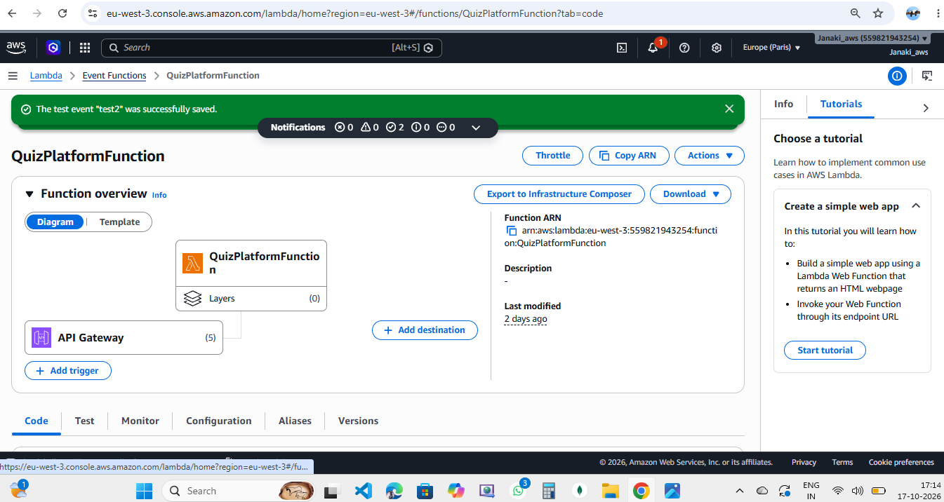

Backend Code
import json
import os
import uuid
from datetime import datetime, timezone
from decimal import Decimal

import boto3
from boto3.dynamodb.conditions import Key

REGION = os.getenv("AWS_REGION", "eu-west-3")
QUESTIONS_TABLE = os.getenv("QUESTIONS_TABLE", "QuizQuestions")
SCORES_TABLE = os.getenv("SCORES_TABLE", "QuizScores")
SNS_TOPIC_ARN = os.getenv("SNS_TOPIC_ARN", "arn:aws:sns:eu-west-3:559821943254:mysns:120dbe7d-ebd6-4737-b7de-c9d1e1d742de")

dynamodb = boto3.resource("dynamodb", region_name=REGION)
questions_table = dynamodb.Table(QUESTIONS_TABLE)
scores_table = dynamodb.Table(SCORES_TABLE)
sns = boto3.client("sns", region_name=REGION)
REGION = os.getenv("AWS_REGION", "eu-west-3")
TABLE_NAME = os.getenv("QUESTIONS_TABLE", "QuizQuestions")

dynamodb = boto3.resource("dynamodb", region_name=REGION)
table = dynamodb.Table(TABLE_NAME)

with open(os.path.join(os.path.dirname(__file__), "..", "data", "quiz_questions.json"), encoding="utf-8") as f:
questions = json.load(f)

with table.batch_writer() as batch:
for question in questions:
batch.put_item(Item=question)

print(f"Inserted {len(questions)} questions into {TABLE_NAME} in {REGION}.")

def response(status, body):
return {
"statusCode": status,
"headers": {
"Content-Type": "application/json",
"Access-Control-Allow-Origin": "*",
"Access-Control-Allow-Headers": "Content-Type,Authorization",
"Access-Control-Allow-Methods": "GET,POST,OPTIONS"
},
"body": json.dumps(body, default=decimal_default)
}

def decimal_default(value):
if isinstance(value, Decimal):
return int(value) if value % 1 == 0 else float(value)
raise TypeError(f"Object of type {type(value).__name__} is not JSON serializable")

def parse_body(event):
raw = event.get("body")
if not raw:
return {}
if event.get("isBase64Encoded"):
import base64
raw = base64.b64decode(raw).decode("utf-8")
return json.loads(raw)

def lambda_handler(event, context):
method = event.get("requestContext", {}).get("http", {}).get("method", event.get("httpMethod", "GET"))
path = event.get("rawPath", event.get("path", "/"))
if method == "OPTIONS":
return response(200, {"ok": True})

try:
if method == "GET" and path.endswith("/questions"):
result = questions_table.scan()
questions = result.get("Items", [])
while result.get("LastEvaluatedKey"):
result = questions_table.scan(ExclusiveStartKey=result["LastEvaluatedKey"])
questions.extend(result.get("Items", []))
# Never send correct answers to the browser before submission.
public_questions = [
{k: v for k, v in q.items() if k != "correctAnswer"}
for q in questions
]
public_questions.sort(key=lambda q: q.get("questionsId", ""))
return response(200, {"questions": public_questions})

if method == "POST" and path.endswith("/submit"):
body = parse_body(event)
participant_id = str(body.get("participantId", "")).strip() or str(uuid.uuid4())
participant_name = str(body.get("participantName", "")).strip()[:80]
answers = body.get("answers", {})
if not participant_name:
return response(400, {"message": "participantName is required."})
if not isinstance(answers, dict):
return response(400, {"message": "answers must be a JSON object."})

result = questions_table.scan()
all_questions = result.get("Items", [])
while result.get("LastEvaluatedKey"):
result = questions_table.scan(ExclusiveStartKey=result["LastEvaluatedKey"])
all_questions.extend(result.get("Items", []))

score = 0
total = 0
for q in all_questions:
marks = int(q.get("marks", 10))
total += marks
if answers.get(q.get("questionsId")) == q.get("correctAnswer"):
score += marks

submitted_at = datetime.now(timezone.utc).isoformat()
record = {
"participantId": participant_id,
"submittedAt": submitted_at,
"participantName": participant_name,
"score": score,
"totalMarks": total,
"answers": answers
}
scores_table.put_item(Item=record)

if SNS_TOPIC_ARN:
try:
sns.publish(
TopicArn=SNS_TOPIC_ARN,
Subject="Quiz result submitted",
Message=f"{participant_name} scored {score}/{total} in the AWS quiz."
)
except Exception:
# Score submission should still succeed if notification is unavailable.
pass

return response(200, {
"message": "Quiz submitted successfully.",
"participantId": participant_id,
"participantName": participant_name,
"score": score,
"totalMarks": total,
"submittedAt": submitted_at
})

if method == "GET" and path.endswith("/leaderboard"):
result = scores_table.scan()
scores = result.get("Items", [])
while result.get("LastEvaluatedKey"):
result = scores_table.scan(ExclusiveStartKey=result["LastEvaluatedKey"])
scores.extend(result.get("Items", []))
scores.sort(key=lambda x: (-int(x.get("score", 0)), str(x.get("submittedAt", ""))))
top_scores = []
for rank, item in enumerate(scores[:50], start=1):
top_scores.append({
"rank": rank,
"participantId": item.get("participantId"),
"participantName": item.get("participantName", "Participant"),
"score": int(item.get("score", 0)),
"totalMarks": int(item.get("totalMarks", 0)),
"submittedAt": item.get("submittedAt", "")
})
return response(200, {"leaderboard": top_scores})

if method == "POST" and path.endswith("/notify"):
if not SNS_TOPIC_ARN:
return response(400, {"message": "Set SNS_TOPIC_ARN on the Lambda environment first."})
body = parse_body(event)
message = str(body.get("message", "Quiz platform notification"))[:1000]
result = sns.publish(TopicArn=SNS_TOPIC_ARN, Subject="Quiz Platform Notification", Message=message)
return response(200, {"message": "Notification published.", "messageId": result.get("MessageId")})

return response(404, {"message": "Route not found", "path": path})
except json.JSONDecodeError:
return response(400, {"message": "Request body must be valid JSON."})
except Exception as exc:
print(f"Unhandled error: {exc}")
return response(500, {"message": "Internal server error. Check Lambda CloudWatch logs."})

10. IAM Permissions
Attach a least-privilege policy to the Lambda execution role. Grant only the actions and table resources needed by each function. The following DynamoDB actions may be required depending on the code:
- dynamodb:GetItem
- dynamodb:PutItem
- dynamodb:Scan
- dynamodb:Query
- dynamodb:UpdateItem
- dynamodb:DescribeTable
Scope permissions to the required QuizQuestions, QuizParticipants and/or QuizScores table ARNs in the eu-west-3 region. Do not grant broad permissions to all AWS resources unless there is a specific requirement.
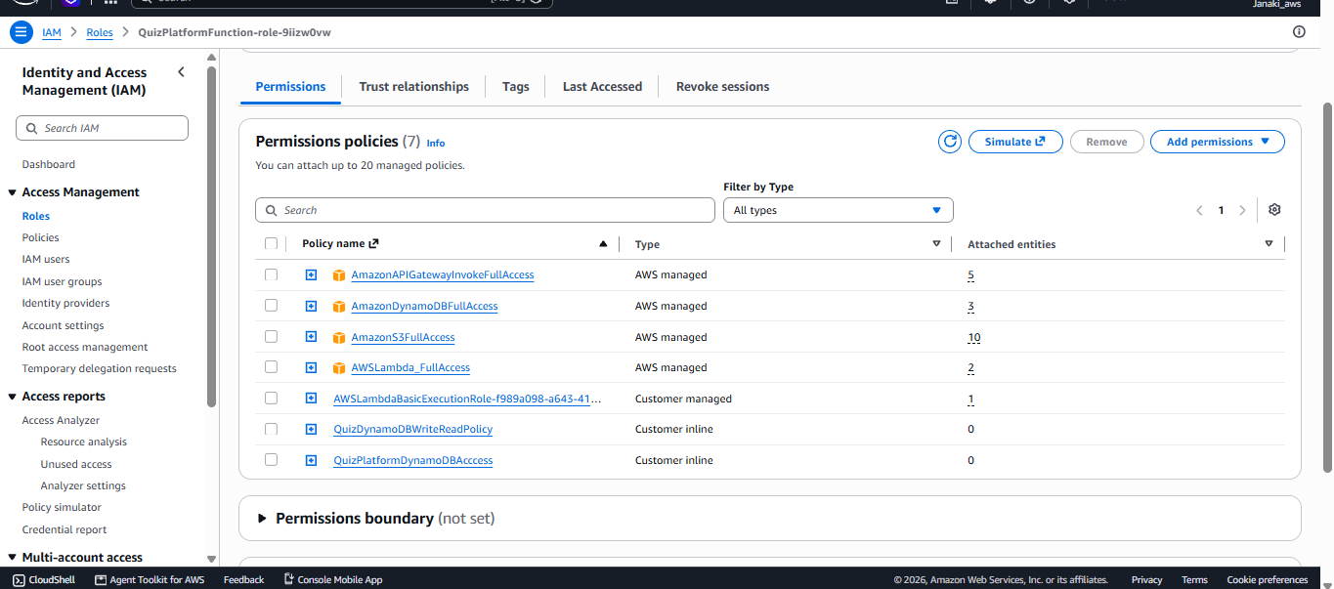

11. API Gateway and CORS Configuration
- Use an API Gateway REST API and create the required resource paths: /questions, /submit and /leaderboard.
- Configure GET for questions and leaderboard, and POST for submit.
- Configure OPTIONS responses for resources called from the browser.
- Allow the frontend origin. During development, Access-Control-Allow-Origin: * may be used for a public, non-credentialed API; for production, prefer the exact frontend origin.
- Allow required headers such as Content-Type and Authorization if used.
- Ensure the allowed methods match each resource, for example GET,POST,OPTIONS as applicable.
- After changing REST API resources or CORS settings, deploy the API to the prod stage again.
Troubleshooting note: A Lambda test returning statusCode 200 does not by itself prove the API Gateway route is deployed correctly. If the browser reports 'Missing Authentication Token', verify the resource path, HTTP method, stage and deployment. If it reports a CORS error, inspect the OPTIONS preflight response as well as the Lambda response headers.

12. Testing and Results
Test | Observed Result | Status
GET /questions | Previously returned HTTP 200 and displayed five AWS-related quiz questions. | Passed
POST /submit | Frontend displayed 'Quiz submitted successfully!' and showed a score of 4 / 5; score saving was confirmed. | Passed
Leaderboard Lambda test | Lambda test returned statusCode 200 with a leaderboard array containing ranked participant records. | Passed
Leaderboard in browser | Frontend showed 'Unable to load leaderboard: Failed to fetch' during troubleshooting. | Pending API/frontend verification

The leaderboard Lambda test output confirmed records including participantName, score and totalQuestions. However, the direct API URL test returned 'Missing Authentication Token' during troubleshooting. This indicates that the API Gateway resource/method/stage deployment still needs to be verified; the Lambda test alone does not confirm the public endpoint.

13. Troubleshooting Checklist
- Check that /leaderboard exists in API Gateway Resources.
- Check that GET is created on /leaderboard and is integrated with the correct Leaderboard Lambda.
- Confirm Lambda proxy integration is configured consistently with the Lambda response format.
- Enable/configure OPTIONS CORS response for /leaderboard.
- Deploy the REST API to the prod stage after any changes.
- Open the direct /leaderboard URL and inspect the response.
- Use browser Developer Tools → Network to inspect the GET request and OPTIONS preflight status.
- Check CloudWatch Logs if the API reaches Lambda but the function fails.
- Verify frontend API_BASE_URL and ensure it does not contain a duplicate or missing path segment.

14. Security Considerations
- Do not place AWS access keys, passwords or other secrets in frontend JavaScript.
- Use least-privilege IAM policies for Lambda execution roles.
- Validate incoming submissions in the backend; do not trust client-calculated scores.
- Limit CORS origins for production deployments where possible.
- Use HTTPS API endpoints and review public S3 access settings carefully.
- Consider throttling, request validation and monitoring before using the application with many participants.

15.Final Output
Real-Time Quiz Competition
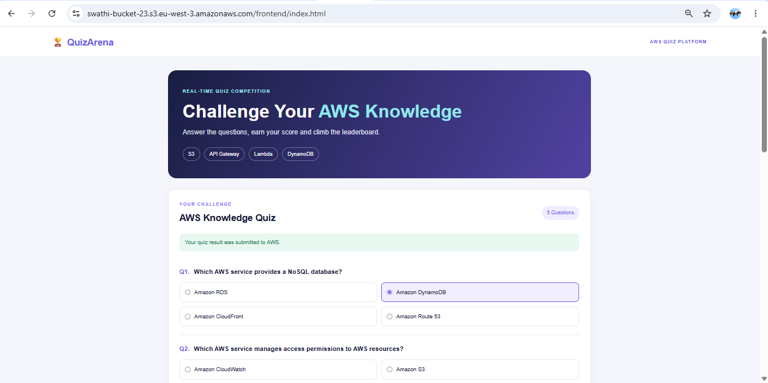

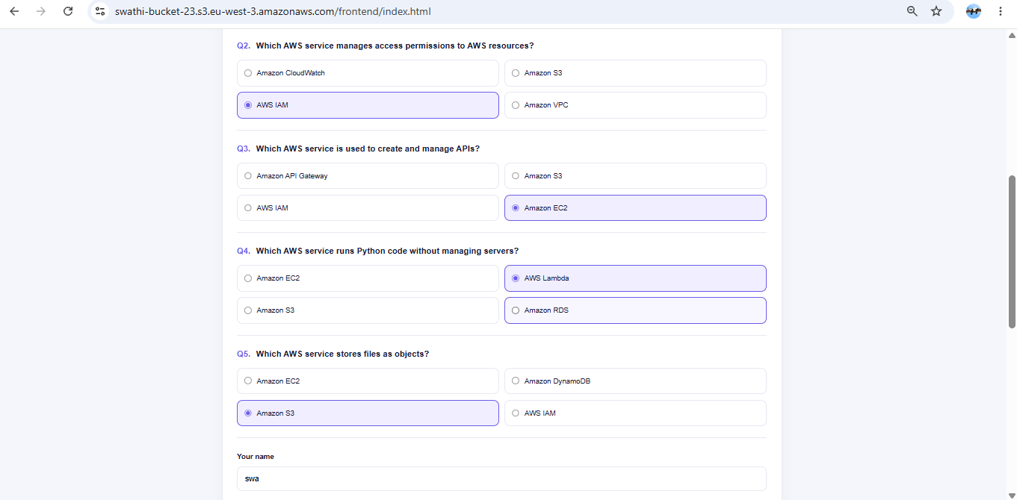

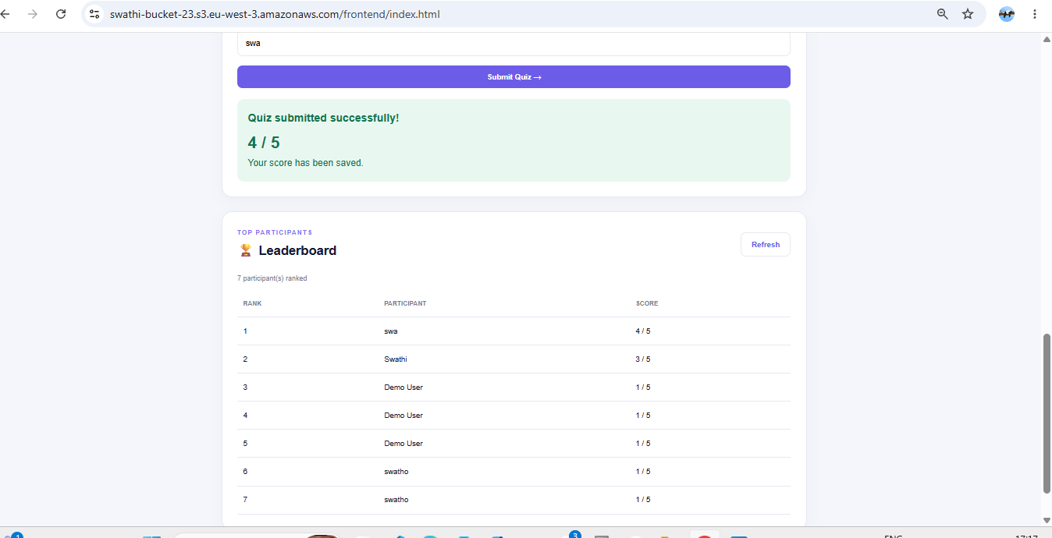

15. Conclusion
The project demonstrates a serverless quiz application using Amazon S3, API Gateway, AWS Lambda, DynamoDB, IAM and CloudWatch. Question retrieval and quiz submission have been tested successfully, and the Leaderboard Lambda returns ranked data during its direct Lambda test. The remaining verification item is to make the deployed API Gateway /leaderboard endpoint accessible from the browser by confirming its GET route, CORS configuration and prod-stage deployment.

— End of Documentation —
Thank you

